Making an S3 Object Public
How I rebuilt bucket "ak-092" with ACLs enabled, uploaded Static.html, and opened it as a live public webpage
Date: 23 September 2026 Region: us-east-1

Quick Overview
This session picked up where the private-bucket exercise left off. Instead of keeping everything locked down, I deliberately set up ak-092 to allow public access: enabling ACLs, turning off the public-access block, uploading a small HTML page, marking that one object public through its ACL, and finally opening it in a browser to confirm it loads for anyone with the link.

Configuration at a Glance
Setting | Value I used
Bucket name | ak-092
Region | us-east-1
Object Ownership | ACLs enabled, Bucket owner preferred
Block Public Access | Turned off, risk acknowledged
Default encryption | SSE-S3, Bucket Key enabled
File uploaded | Static.html, 15.4 KB
Public access action | Make public using ACL (on Static.html)
Result | Object publicly viewable at its S3 Object URL

Step 1: Starting a Fresh Bucket and Enabling ACLs from the Start
I returned to the Create bucket form for a bucket named ak-092, again in us-east-1 with the General purpose type and Global namespace. This time my plan was different from a basic private bucket: I wanted the object itself to be reachable as a public webpage, so I began by allowing ACLs instead of leaving them off.
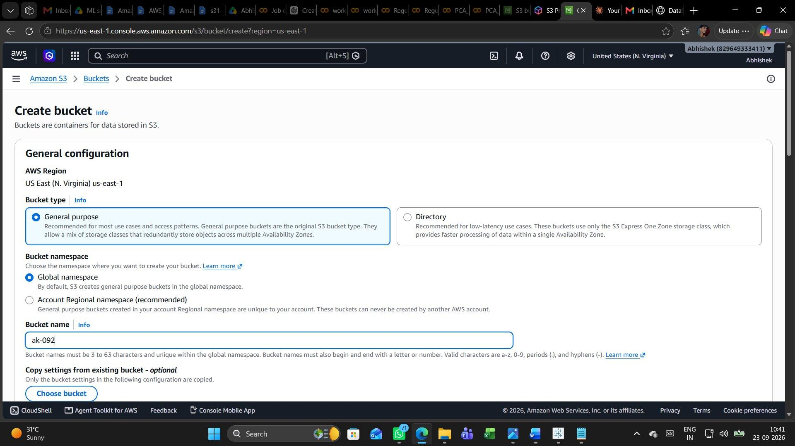

Step 2: Choosing "ACLs enabled" for Object Ownership
In the Object Ownership section I switched away from the recommended "ACLs disabled" option and selected "ACLs enabled" instead, with "Bucket owner preferred" chosen underneath it. AWS displayed its usual warning that disabling ACLs is the safer default, but enabling them here lets objects be shared individually through ACL permissions rather than only through bucket-wide policies, which was what my next steps needed.
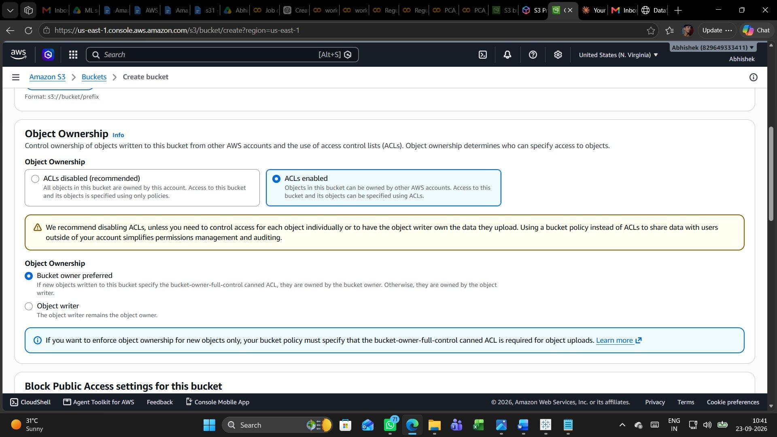

Step 3: Turning Off Block Public Access and Acknowledging the Risk
Scrolling to Block Public Access, I unchecked "Block all public access" along with its four sub-options. A yellow warning appeared explaining that this could make the bucket and its objects public, and AWS still recommends keeping the block on unless public access is genuinely needed, for example for static website hosting. Since that was exactly my intention, I ticked the acknowledgement checkbox confirming I understood the risk.
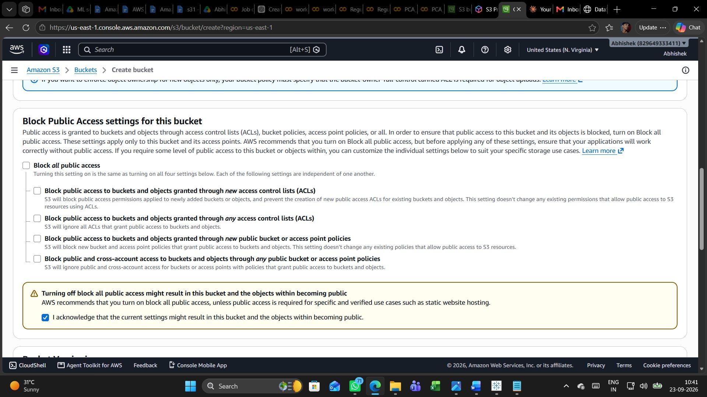

Step 4: Confirming Encryption and Creating the Bucket
Lower down, Default encryption was left on Server-side encryption with Amazon S3 managed keys (SSE-S3) with Bucket Key enabled, the same safe default as before — opening up public access to objects does not require weakening encryption. With everything set, I clicked the orange Create bucket button to finish the setup.
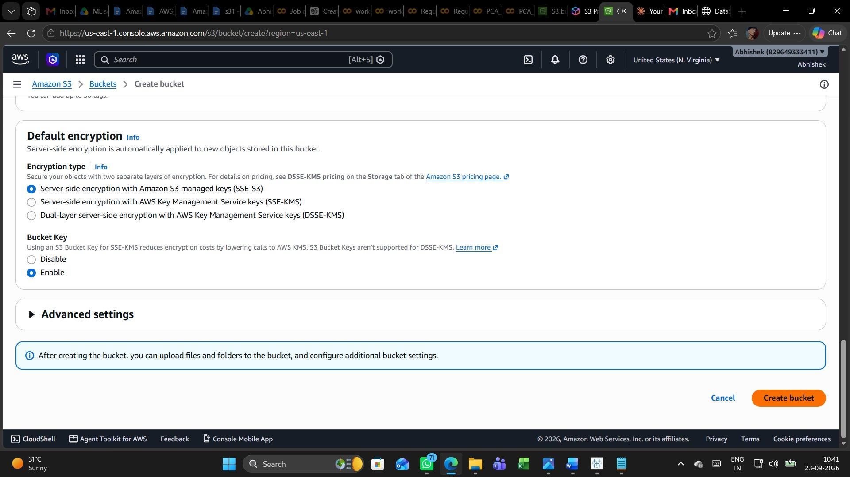

Step 5: Bucket Created Successfully
S3 confirmed the result with a green banner: Successfully created bucket "ak-092". The Objects tab opened showing Objects (0), meaning the bucket existed but was still empty, ready for its first file.
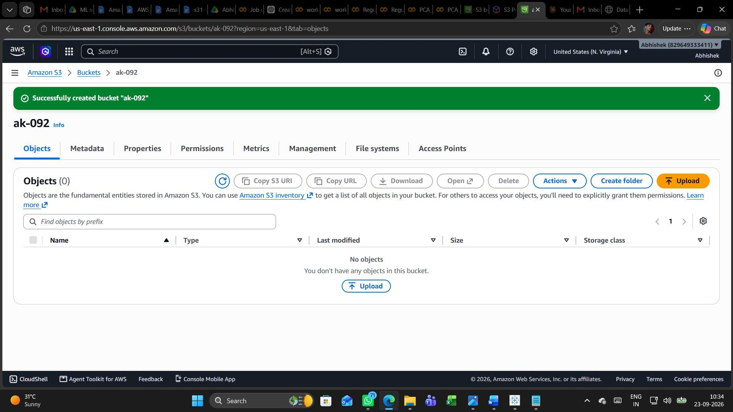

Step 6: Opening the Upload Page
I clicked Upload to reach the file-selection screen. At this point Files and folders showed (0) with the message "You have not chosen any files or folders to upload", and the Destination panel confirmed the target as s3://ak-092, ready for me to add a file with Add files or Add folder.
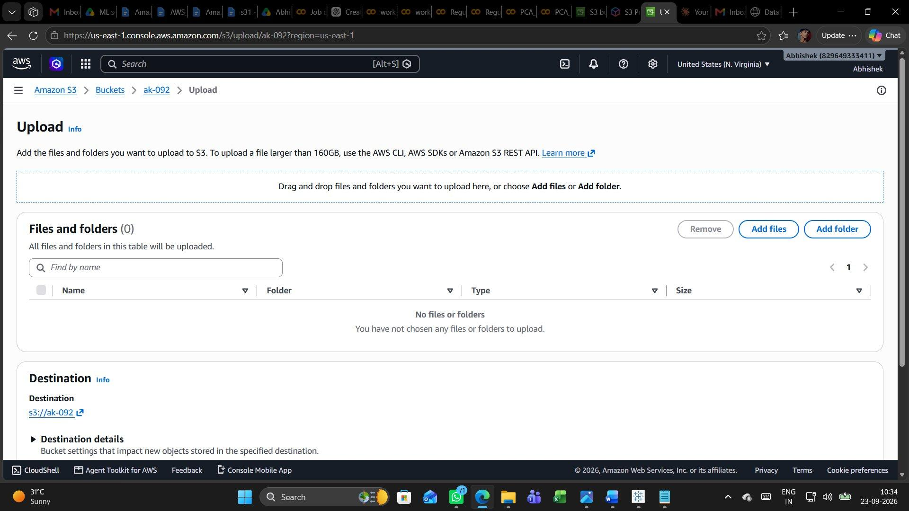

Step 7: Reviewing the Uploaded Static.html Object
After uploading, I opened the new object's Properties page. It showed the file name Static.html, size 15.4 KB, type html, last modified September 23, 2026 at 10:34:46 (UTC+05:30), along with its S3 URI, ARN, ETag, Key and Object URL — the same detail set S3 always shows, but this time for a webpage file rather than a document.
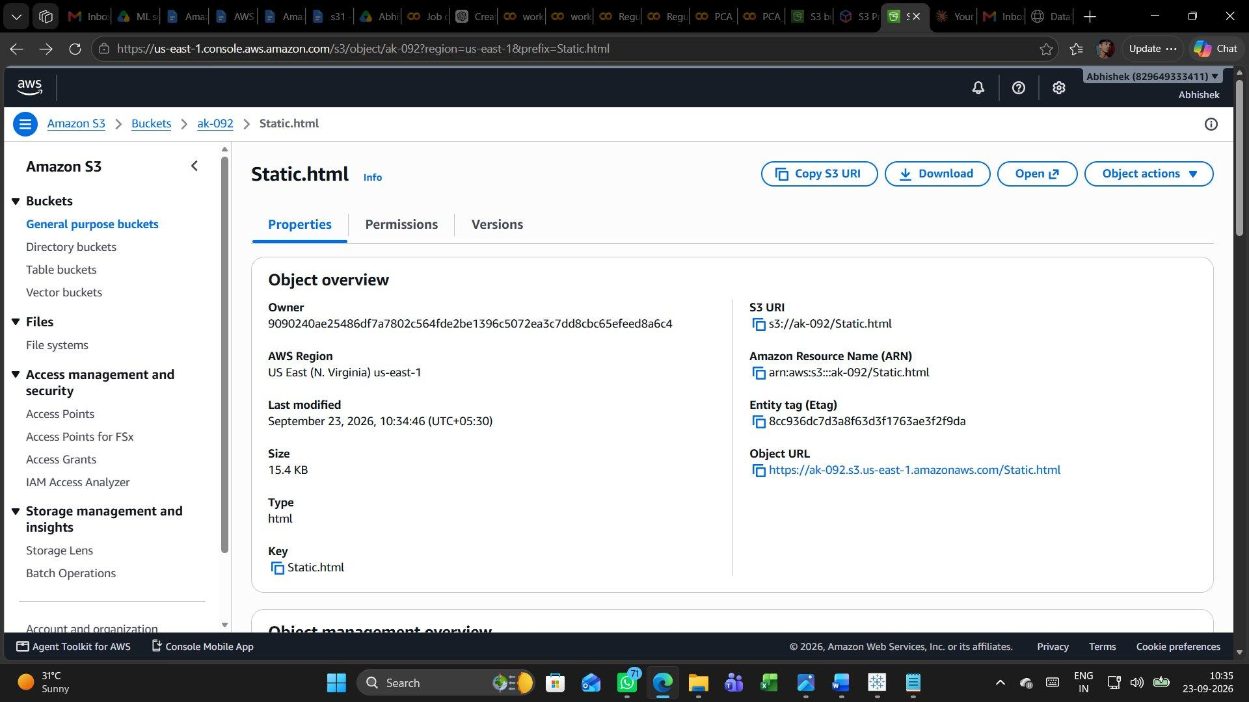

Step 8: Confirming the File in the Objects List
Back on the bucket's Objects tab, the list now read Objects (1) with Static.html listed as an html file of 15.4 KB, Standard storage class, uploaded at 10:34:46. I selected its checkbox to prepare for the next action: making it publicly viewable.
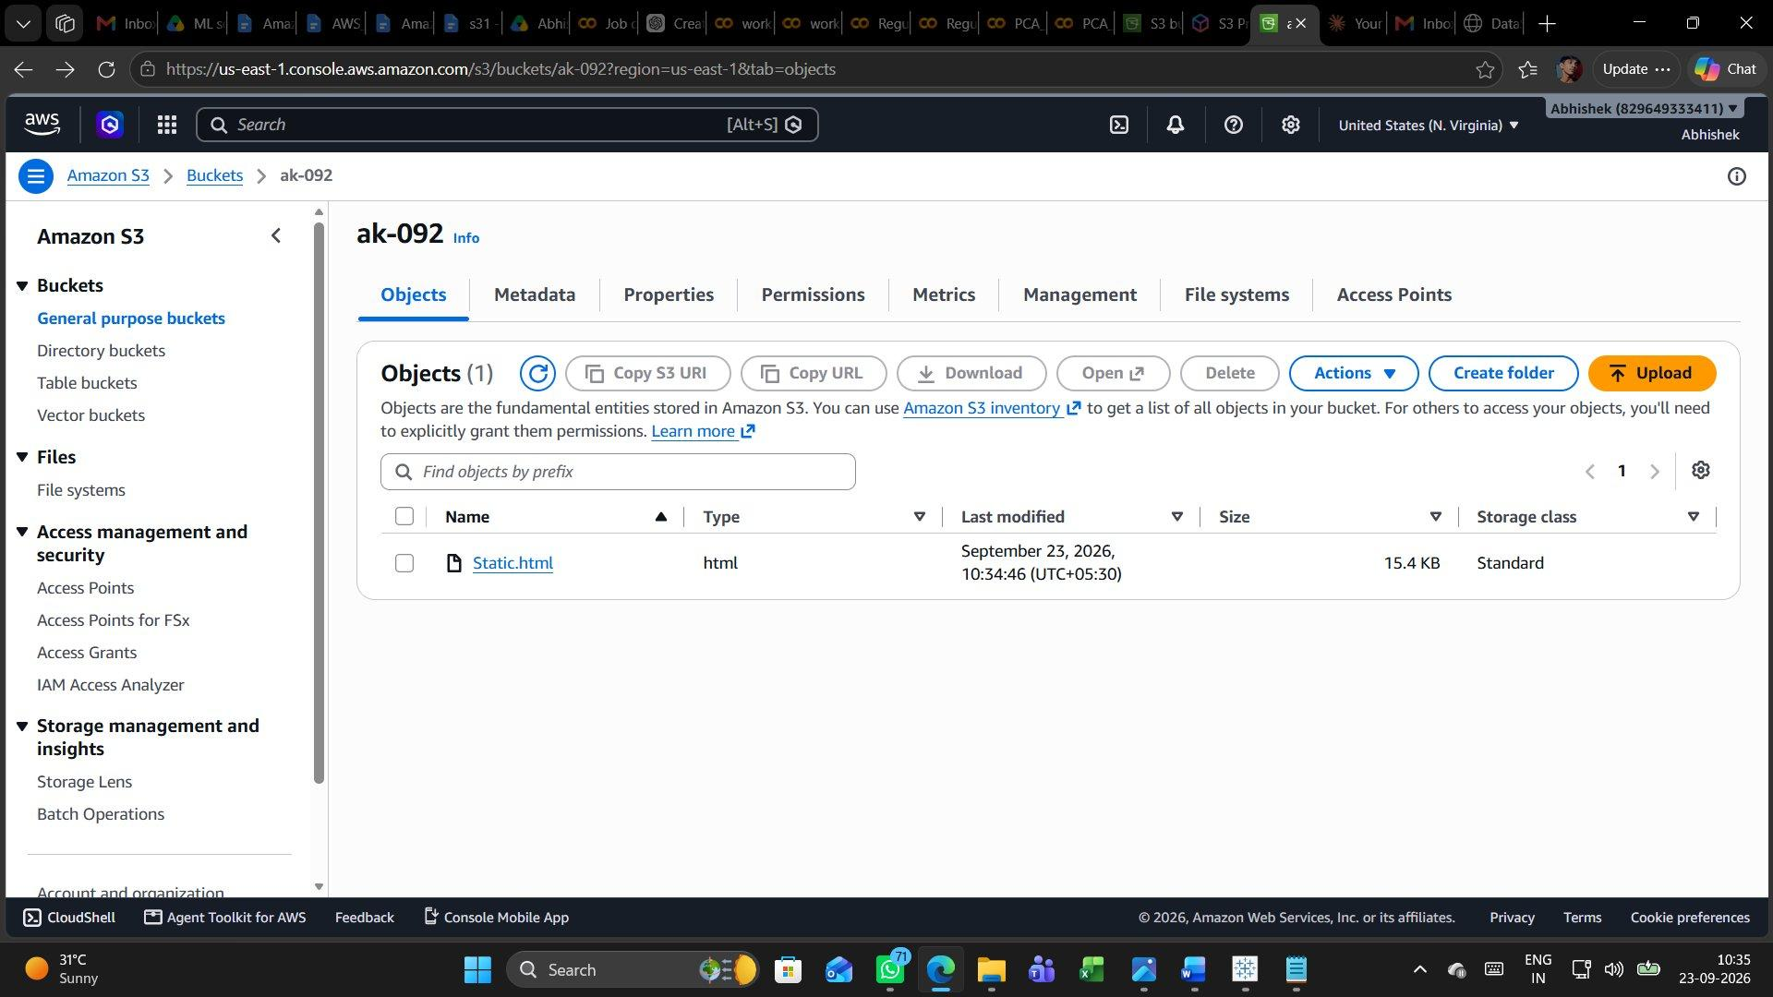

Step 9: Opening Actions and Choosing "Make public using ACL"
With Static.html selected, I opened the Actions dropdown, which lists options such as Download as, Share with a presigned URL, Copy, Move, Rename object and Edit tags. Because I had enabled ACLs and disabled the public-access block earlier, the option "Make public using ACL" was available, and I selected it to grant public read access to this one object.
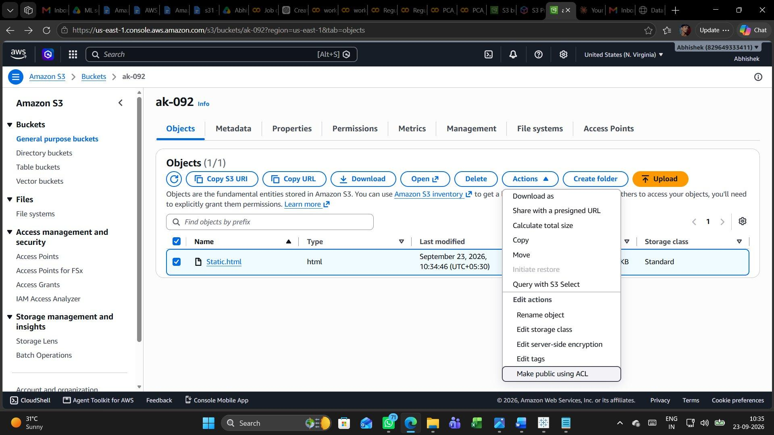

Step 10: Public Access Successfully Applied
The Make public: status page reported "Successfully edited public access", with the summary confirming 1 object (15.4 KB) succeeded and 0 objects failed. The "Failed to edit public access" table was empty, verifying the ACL change went through cleanly for Static.html.
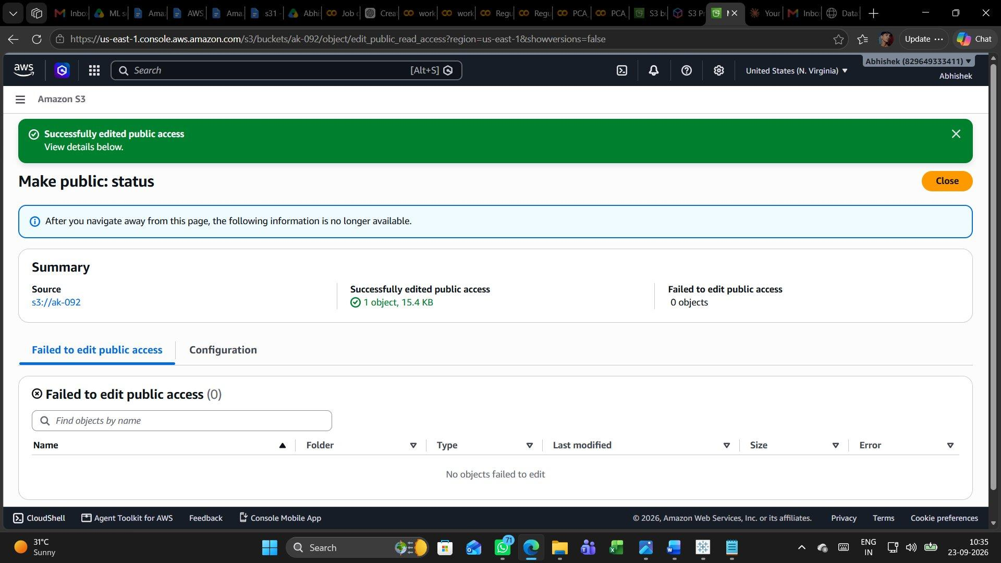

Step 11: Copying the Public Object URL
I went back into the object's Properties page to grab its Object URL, https://ak-092.s3.us-east-1.amazonaws.com/Static.html, shown highlighted at the bottom of the browser as I hovered over the link. With the ACL applied, this URL is now the direct, public address of the file rather than a link that would require sign-in.
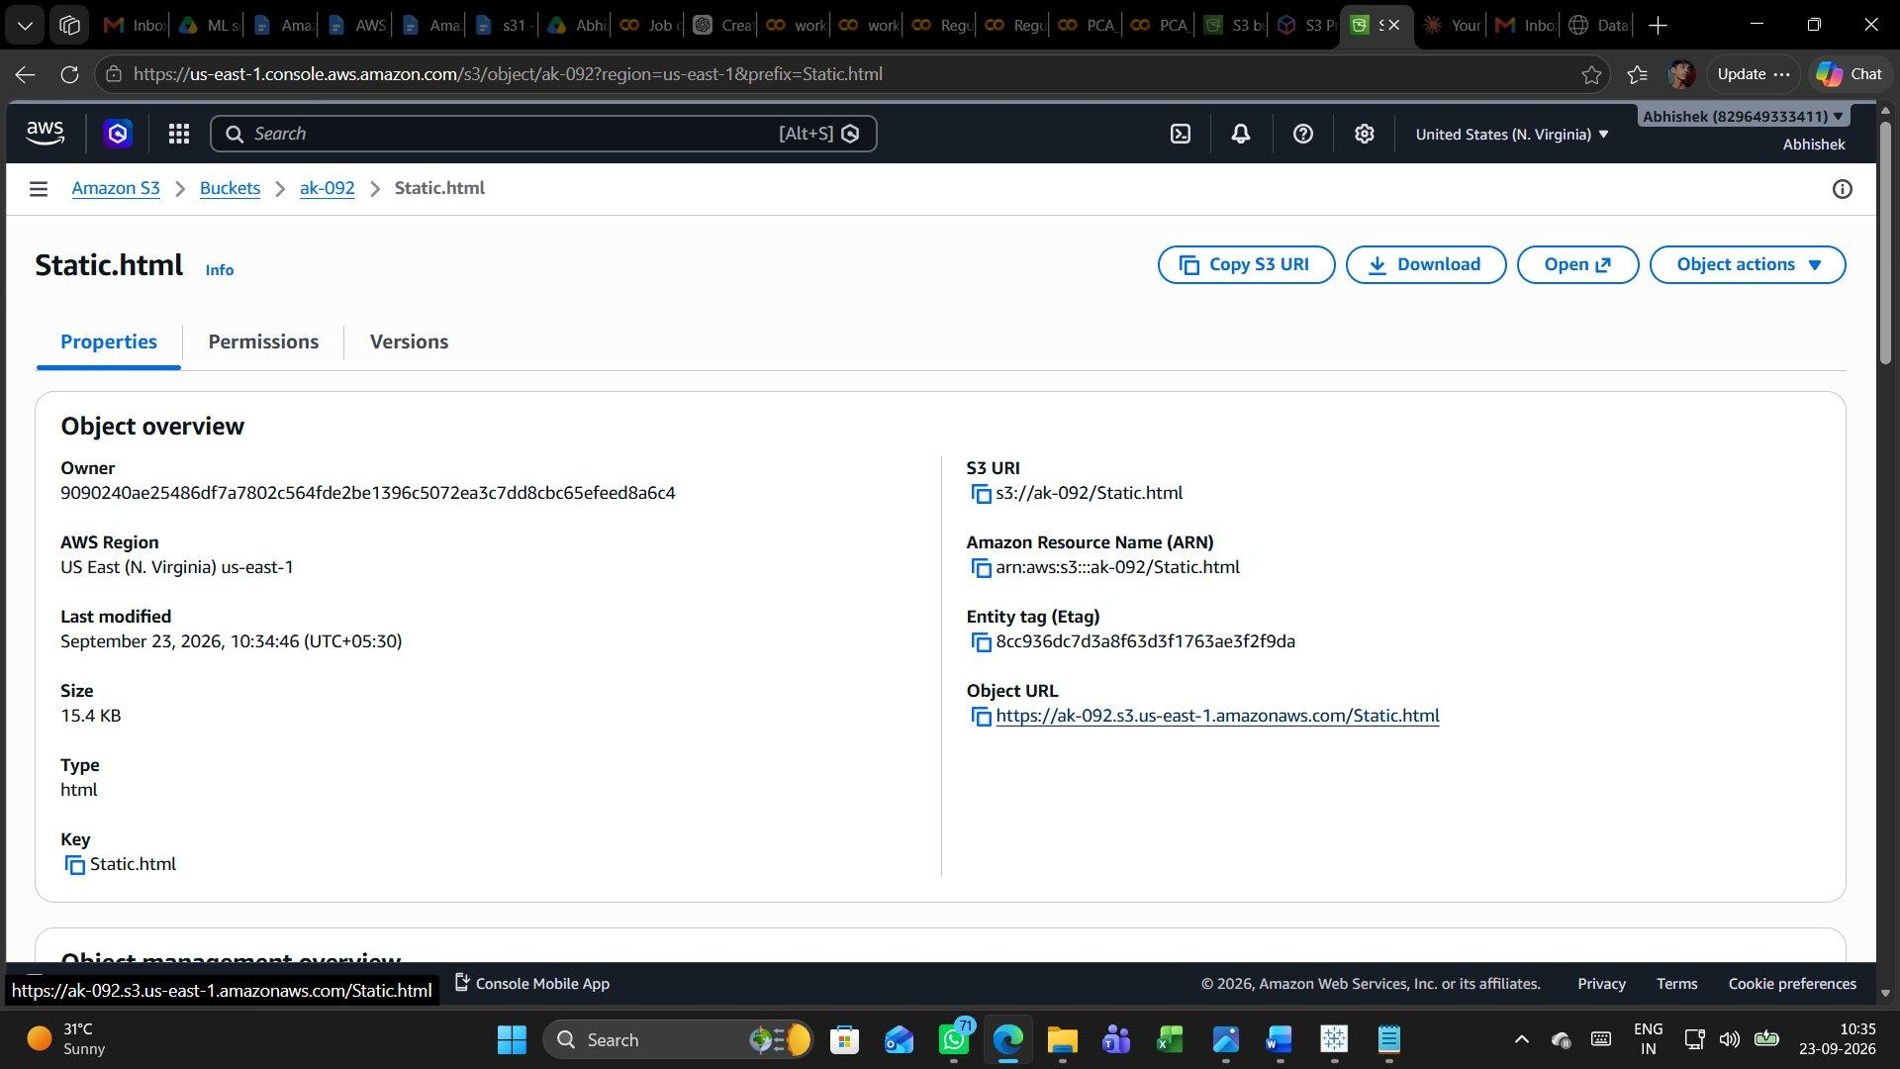

Step 12: Viewing the Live Page in the Browser
Pasting that Object URL into a new tab loaded the page directly from S3 with no login prompt. It rendered as a complete "DataScience Hub" landing page, with a navigation bar (Home, Skills, Roadmap, Projects, Contact), a headline about learning data science, a Data Analytics bar chart, and Start Learning / View Projects buttons — proof that the object was genuinely public and being served straight out of the S3 bucket.


My Full Summary of the Session
This exercise was about the opposite of my earlier, locked-down bucket: I wanted one file inside ak-092 to be genuinely public. That decision had to be made early, during bucket creation, because S3 nudges you toward privacy by default. In the Create bucket form I switched Object Ownership to "ACLs enabled" instead of the recommended disabled setting, and in Block Public Access I unchecked "Block all public access" and its four sub-settings, ticking the acknowledgement box that confirms I understood the bucket could become public. Encryption stayed on SSE-S3 with Bucket Key enabled, since public readability and server-side encryption are independent concerns.
Once the bucket existed, I uploaded a small landing-page file, Static.html (15.4 KB), and confirmed it in the Objects list. Uploading alone does not make a file public, though — even with the block disabled, each object stays private until you say otherwise. So I selected the file, opened the Actions menu, and chose "Make public using ACL". The status page reported success for that one object with zero failures, which is exactly the confirmation I needed before trusting the link.
To prove the setting had really taken effect, I opened the object's Properties tab again and copied its Object URL, then pasted that URL into a fresh browser tab. The page loaded immediately with no sign-in step, rendering a full "DataScience Hub" landing page with navigation, a hero section and a chart. That end-to-end check — from ACL settings, to upload, to a live public URL — is the part that makes this workflow trustworthy: I did not just flip a setting, I watched the object actually behave the way that setting promised.
The bigger lesson from this session is that public access on S3 is deliberately a multi-layer decision: the bucket has to allow ACLs and drop its public-access block, and then each object still needs its own ACL applied before it is reachable. That layering is what keeps accidental exposure rare. Going forward, if I only need this for a short demo, the responsible next step is to remove the public ACL from Static.html, or delete the object and bucket entirely, once the page has served its purpose.

